Count Inversions of an Array:-
Optimal Approach
Algorithm / Intuition
Observation:
Assume two sorted arrays are given i.e. a1[] = {2, 3, 5, 6} and a2[] = {2, 2, 4, 4, 8}. Now, we have to count the pairs i.e. a1[i] and a2[j] such that a1[i] > a2[j].
In order to solve this, we will keep two pointers i and j, where i will point to the first index of a1[] and j will point to the first index of a2[]. Now in each iteration, we will do the following:
- If a1[i] <= a2[j]: These two elements cannot be a pair and so we will move the pointer i to the next position. This case is illustrated below:
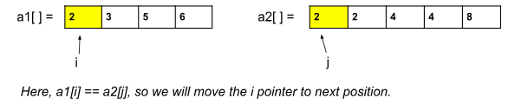
- Why we moved the i pointer: We know, that the given arrays are sorted. So, all the elements after the pointer j, should be greater than a2[j]. Now, as a1[i] is smaller or equal to a2[j], it is obvious that a1[i] will be smaller or equal to all the elements after a2[j]. We need a bigger value of a1[i] to make a pair and so we move the i pointer to the next position i.e. next bigger value.
- If a1[i] > a2[j]: These two elements can be a pair and so we will update the count of pairs. Now, here, we should observe that as a1[i] is greater than a2[j], all the elements after a1[i] will also be greater than a2[j] and so, those elements will also make pair with a2[j]. So, the number of pairs added will be n1-i (where n1 = size of a1[ ]). Now, we will move the j pointer to the next position. This case is also illustrated below:
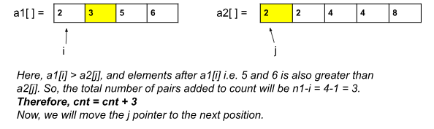
The above process will continue until at least one of the pointers reaches the end.
Until now, we have figured out how to count the number of pairs in one go if two sorted arrays are given. But in our actual question, only a single unsorted array is given. So, how to break it into two sorted halves so that we can apply the above observation?
We can think of the merge sort algorithm that works in a similar way we want. In the merge sort algorithm, at every step, we divide the given array into two halves and then sort them, and while doing that we can actually count the number of pairs.
Basically, we will use the merge sort algorithm to use the observation in the correct way.
Approach:
The steps are basically the same as they are in the case of the merge sort algorithm. The change will be just a one-line addition inside the merge() function. Inside the merge(), we need to add the number of pairs to the count when a[left] > a[right].
The steps of the merge() function were the following:
- In the merge function, we will use a temp array to store the elements of the two sorted arrays after merging. Here, the range of the left array is low to mid and the range for the right half is mid+1 to high.
- Now we will take two pointers left and right, where left starts from low and right starts from mid+1.
- Using a while loop( while(left <= mid && right <= high)), we will select two elements, one from each half, and will consider the smallest one among the two. Then, we will insert the smallest element in the temp array.
- After that, the left-out elements in both halves will be copied as it is into the temp array.
- Now, we will just transfer the elements of the temp array to the range low to high in the original array.
Modifications in merge() and mergeSort():
- In order to count the number of pairs, we will keep a count variable, cnt, initialized to 0 beforehand inside the merge().
- While comparing a[left] and a[right] in the 3rd step of merge(), if a[left] > a[right], we will simply add this line:
cnt += mid-left+1 (mid+1 = size of the left half)
- Now, we will return this cnt from merge() to mergeSort().
- Inside mergeSort(), we will keep another counter variable that will store the final answer. With this cnt, we will add the answer returned from mergeSort() of the left half, mergeSort() of the right half, and merge().
- Finally, we will return this cnt, as our answer from mergeSort().
Code
import java.util.*;
class Solution {
private static int merge(int[] arr, int low, int mid, int high) {
ArrayList<Integer> temp = new ArrayList<>();
int left = low;
int right = mid + 1;
//Modification 1: cnt variable to count the pairs:
int cnt = 0;
//storing elements in the temporary array in a sorted manner//
while (left <= mid && right <= high) {
if (arr[left] <= arr[right]) {
temp.add(arr[left]);
left++;
} else {
temp.add(arr[right]);
cnt += (mid - left + 1); //Modification 2
right++;
}
}
// if elements on the left half are still left //
while (left <= mid) {
temp.add(arr[left]);
left++;
}
// if elements on the right half are still left //
while (right <= high) {
temp.add(arr[right]);
right++;
}
// transfering all elements from temporary to arr //
for (int i = low; i <= high; i++) {
arr[i] = temp.get(i - low);
}
return cnt; // Modification 3
}
public static int mergeSort(int[] arr, int low, int high) {
int cnt = 0;
if (low >= high) return cnt;
int mid = (low + high) / 2 ;
cnt += mergeSort(arr, low, mid); // left half
cnt += mergeSort(arr, mid + 1, high); // right half
cnt += merge(arr, low, mid, high); // merging sorted halves
return cnt;
}
public static int numberOfInversions(int[] a, int n) {
return mergeSort(a, 0, n - 1);
}
public static void main(String[] args) {
int[] a = {5, 4, 3, 2, 1};
int n = 5;
int cnt = numberOfInversions(a, n);
System.out.println("The number of inversions are: " + cnt);
}
}

Output: The number of inversions is: 10
Complexity Analysis
Time Complexity: O(N*logN), where N = size of the given array.
Reason: We are not changing the merge sort algorithm except by adding a variable to it. So, the time complexity is as same as the merge sort.
Space Complexity: O(N), as in the merge sort We use a temporary array to store elements in sorted order.

